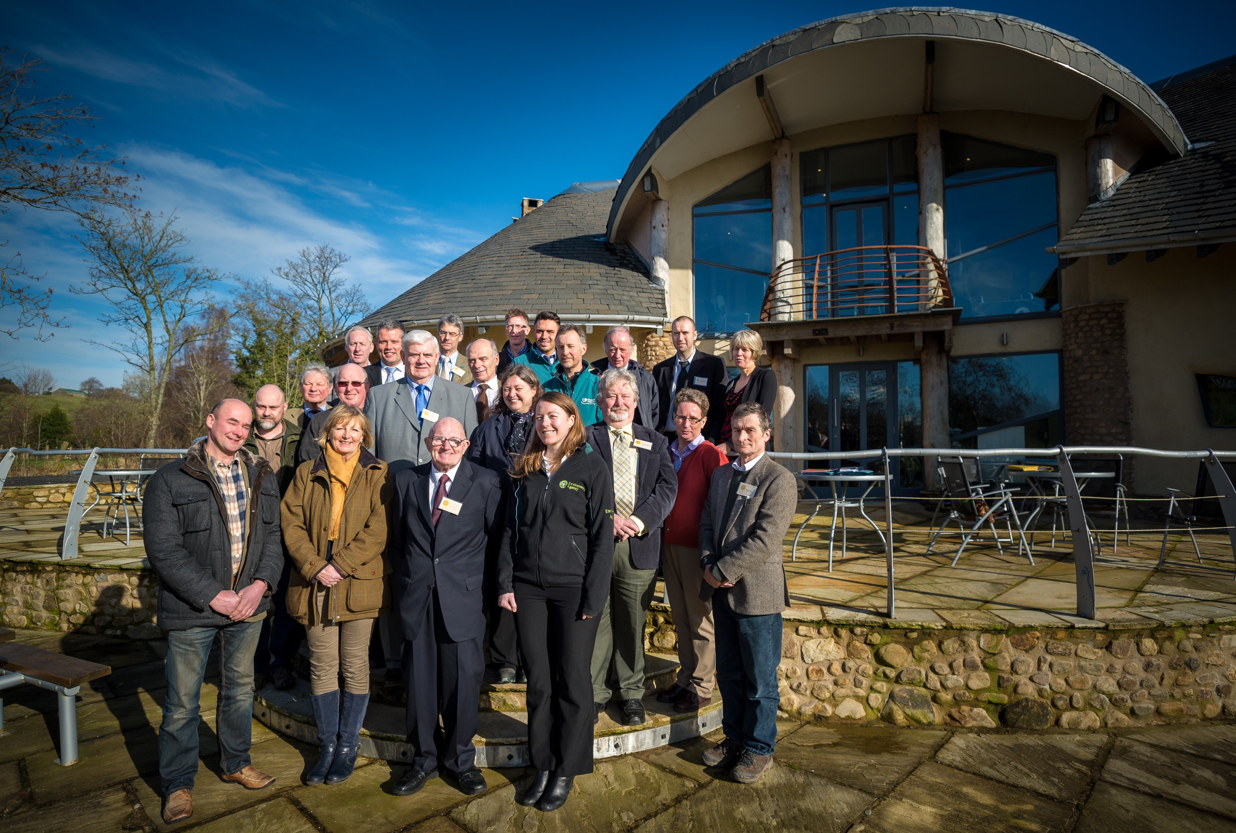
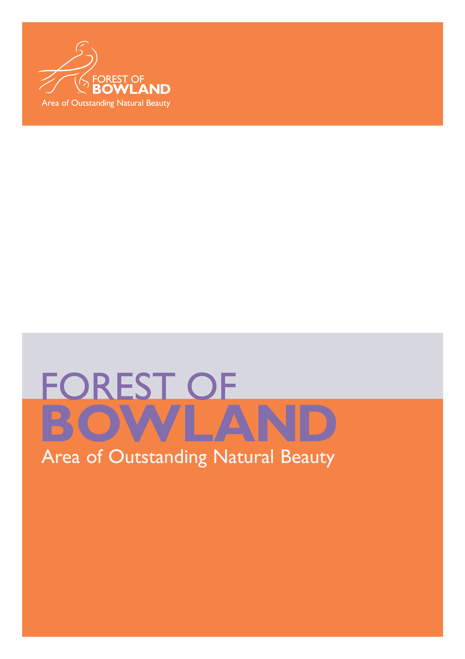
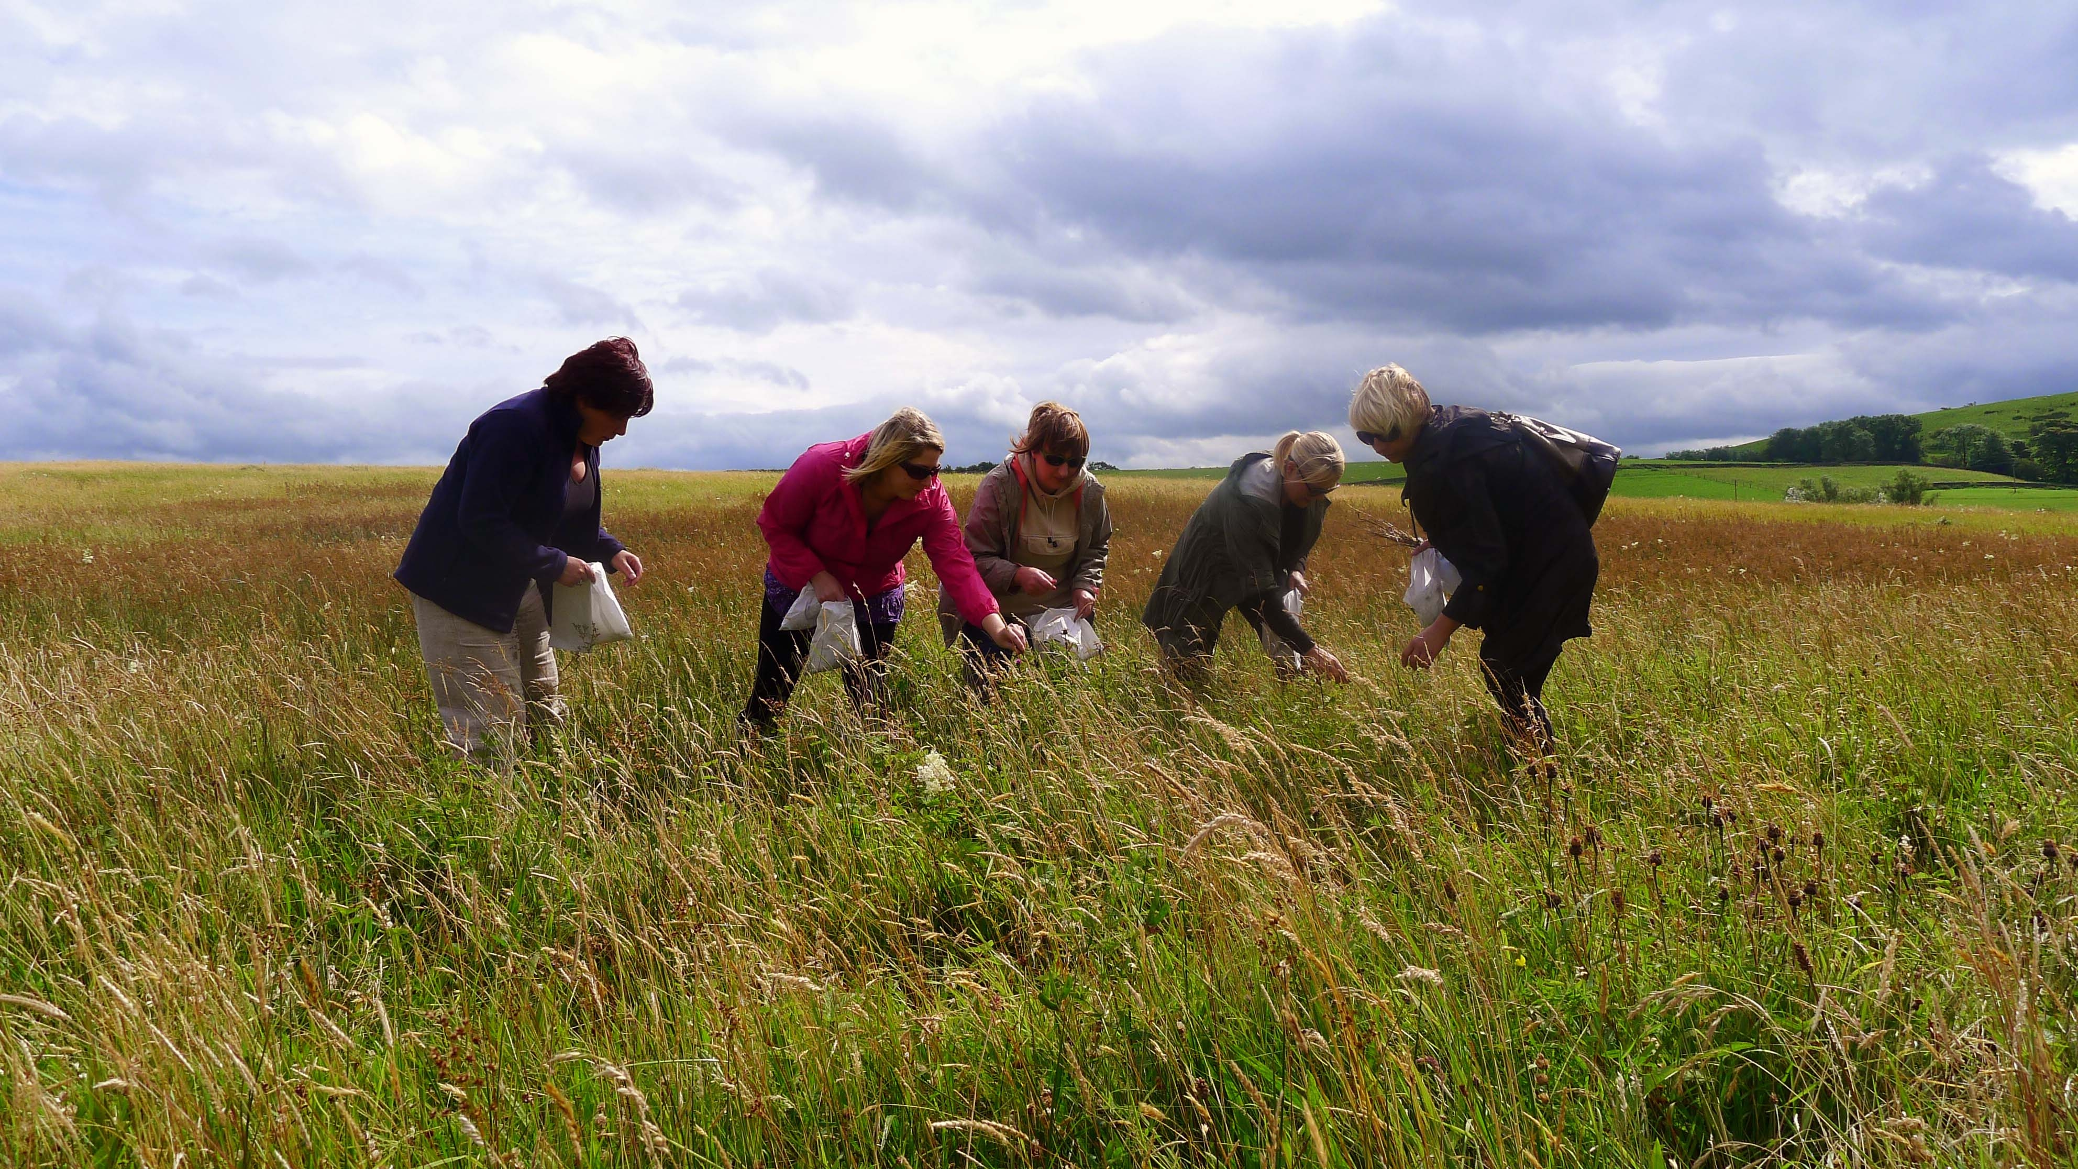
AONB Report to JAC: April 2014

An outstanding landscape of natural and cultural heritage

Bowland Hay Time Project
The Bowland Hay Time project which came to a close at the end March 2014 has enabled practical restoration work to take place on over 50 hectares of meadow land in Bowland; 25% more than the target area, and has surveyed 92 grassland sites throughout the AONB area as a contribution to the BHS project. The project has delivered public facing events throughout 2012 and 2013 far in excess of the target of 10 events, and has gathered a dedicated group of volunteers.
Other project successes:
- 24 people trained in identification skills
- 55 volunteers involved
- 209 attendees at public events
- 21 volunteer days for young people
- 26 people taught to mow
To view a copy of the final project report visit www.forestofbowland.com/haytimeproject
For further information contact sarah.robinson@lancashire.gov.uk

Networks for Nectar
Leading on from the successful Bowland Hay Time Project the new Networks for Nectar project is looking at improving biodiversity by restoring and conserving small, species-rich grasslands to link up with the area's best wildflower meadows and providing a haven for invertebrates such as bees. This is a partnership project between the Forest of Bowland AONB and the Yorkshire Dales Millennium Trust, supported by the Lancashire Environment Fund. The project will run for 18 months and involves local volunteers working on meadow management, seed harvesting/propagating, and planting plug plants. This project is building on the work of the successful Hay Time project which has restored wild flowers to 25 traditional hay meadows across Bowland over the last two years. The outcome - which we hope to see and build on over the next few years - is meadows with increasingly valuable habitat, providing new homes for bees, butterflies and other pollinators.
For further information contact sarah.robinson@lancashire.gov.uk

Wolf Fell Peat Restoration and Public Access Improvements
As part of a new Higher Level Stewardship agreement with Natural England the upper parts of Wolf Fell has been fenced off and associated bare peat restoration work carried out. The eroding path across the top of the fell has been restored using a sub-soil path technique.
For more information contact tarja.wilson@lancashire.gov.uk

Priority Peat and EU LIFE Bid
Over the last six months Sarah Robinson has been working for the AONB in a consultancy capacity to increase our knowledge of the state of the moorland peat in the area and also across the West Pennine Moors and Rossendale, the latter study was on behalf of the Lancashire Peat Partnership and funded by the Environment Agency. The work has built on a desktop study carried out earlier, and it provides us with a detailed information matrix identifying where work is still required, and in particular the area of bare peat, and the length of grips and gullies, which need restoring. The study includes detailed GIS mapping, aerial and site photographs, and will be available to download from the AONB website shortly.
This information, together with outline costings and discussions with landowners, will enable Bowland and the rest of Lancashire to be included in a wider Pennine Peat Partnership bid for European funding under the LIFE programme which comes on stream this year. This funding would enable the AONB to manage a further programme of peatland restoration work, bringing all of our fells and this vitally important habitat back into good condition – providing an ideal site for wildlife, reducing run off and the risk of flooding and discoloured water, retaining a vital carbon store and in the future enabling more carbon to be sequestered from the atmosphere.
For further information contact sarah.robinson@lancashire.gov.uk

Undergrounding for Visual Amenity Programme
The natural beauty of Beacon Fell Country Park, which welcomes more than 200,000 visitors a year, has been successfully restored thanks to the removal of electricity poles and power lines.
Further to the earlier schemes reported, Electricity Northwest working alongside the Forest of Bowland AONB and Lancashire County Council Countryside Service have successfully replaced the power lines with 2.5km of underground cable to improve the views from the fell close to the Bowland Visitor Centre.

The work forms part of a £5.4m five-year OFGEM Undergrounding for Visual Amenity (UVA) programme to replace lines identified as being most visually intrusive in the North West.

For further information contact elliott.lorimer@lancashire.gov.uk

Resilient and sustainable rural communities

Bowland's Artistic Talent Soon to be "Revealed"
Lancashire Arts Development, Ribble Valley Arts Development and the Forest of Bowland AONB have successfully appointed an artist manager for the community engagement element of Bowland Revealed – the exciting new arts offer being developed as part of the AONB's 50th anniversary celebrations.
Following consideration of a number of inspiring and creative bids from professional arts organisations, Melling-based Green Close Studio have been contracted to deliver their proposal entitled, "50 years in the making". The project, which will run from June to December, will work to engage and involve local communities, visitors, schools and artists through a series of workshops and events. Keep an eye on the website for updates and the chance to bring out your inner artist!
We are also preparing to send out a brief for the second strand of Bowland Revealed known as "Landmarks". The brief will lead to a major, outdoor, visual arts commission in the form of an ambitious, temporary artwork sited within, and drawing inspiration from, the landscape. Whilst looking to challenge and delight audiences, proposals will need to demonstrate a real awareness, understanding and respect for the nature of the AONB environment, its habitats and wildlife.
We are currently awaiting the outcome of a bid to Arts Council England's Grants for the Arts programme which, if successful, will allow us to offer commissions to both an established, and an emerging, artist. Without ACE support the Landmarks project will still go ahead, but on a smaller scale. The brief(s) will be circulated in early May so, if you are an artist interested in submitting a proposal, or know someone who might be, then do get in touch.

For further information contact sandra.silk@lancashire.gov.uk

Champion Bowland
A number of small grants have been awarded since October 2013, these include:
- "By Hodder and Beyond" - book of poetry by J. M. Breaks (Slaidburn) - £330
- Dunsop Green Footpath Restoration - £654
- Bowland Best Kept Village Competition 2014 (covering Lancashire and Yorkshire) - £500
- Gisburn Forest Labyrinth - £600

£5,422 is available for grant applications. Visit www.championbowland.org.uk for further information.

For further information contact mike.pugh@lancashire.gov.uk

Bowland Experience

The main income for the last 6 months has been generated as follows:
- 50th Anniversary Calendar sales and advertising in the AONB Anniversary Discovery Guides - £4,300
- Business promotion within AONB leaflets (re-printing of Bentham village leaflet and Gisburn Forest Mountain Bike trails leaflet) - £1,362

Membership
- 6 new members in last 6 months
- Total now 109

Business Monitoring
The aim of the project is to provide data on business performance amongst the members of the Bowland Experience on a regular basis. The research has been carried out biannually since November 2012 by consultants QA Research. Results from November 2013 found that:
- Visitor Numbers – 62% reported an increase (vs. 42% in November 2012)
- Business Performance – 86% Quite or Very satisfied (vs. 74% in November 2012)
- Next 6 months' prospects – 92% Fairly or Very confident (vs. 82% in November 2012)

Sustainable Tourism
Our congratulations go out to a number of Bowland businesses who have not only excelled at the regional Marketing Lancashire Tourism awards, but who have been announced as finalists in the prestigious VisitEngland Awards for Excellence 2014. Very well done to Bleasdale Self Catering Cottages, named as a finalist in the Sustainable Tourism Award Category; The Parkers Arms, in the Taste of England Category and the Visit Garstang Centre, in the Information Provider of the Year Category.
These finalists now go forward to the glittering awards ceremony which is being held on Monday 12 May 2014, at Cheltenham Racecourse. They will have to wait until the ceremony to find out which award they will receive, but all finalists are guaranteed to receive a Gold, Silver, Bronze or Highly Commended Award. We wish them all the very best for the event.
Hetty Byrne was invited to speak at the 8th International Conference on Responsible Tourism in Destinations on 3 April organised by Manchester Metropolitan University and Visit England, which was held for the first time in the UK. Hetty presented a case study about the Forest of Bowland and the successful work of the partnership in developing a sustainable destination, as part of a panel addressing 'What Does Success Look Like?' Projects such as Access for All, Visitor Giving, and the Bowland Wildlife Blog were all highlighted as examples of good practice, delivered by the AONB unit with partners and the sustainable tourism business network – The Bowland Experience.

For further information contact hetty.byrne@lancashire.gov.uk

Sustainable Development Fund
Last year SDF supported nine projects:
Applicant | Project | Grant awarded
Bowland Experience | Electric Bicycle Network | £1752
Anita Burrows (artist) | Bowland Now and Then | £230
Dunsop Bridge village hall | Insulation, windows, zoned heating | £4000
Yorks Dales Millennium Trust | Pilot community outreach project | £2735
Bleasdale parish hall | Buffer tank for wood pellet boiler, energy seminar for community groups | £2492
LESS | Energy efficiency advice | £4337
Diane Hubbard | Energy efficiency research | £1000
RSPB | Long Preston Wet Grassland: bird hide | £1500
Thornley community space | Village hall renovation: insulation & glazing | £5000
£23,046

As reported in October, we have set up an arrangement with Champion Bowland so that they are now the grants distributor for SDF, although an independent grant panel is still run for the scheme by the AONB Unit. This arrangement has enabled us to offer all projects a 12 month period in which to spend their grant money, thus overcoming the pressure on applicants having to complete works for the end of our financial year. This has meant that four projects have not yet claimed their grants, and these monies will continue to be held by Champion Bowland for them until the end of December 2014. If for any reason grants are unclaimed then the money will be retained and re-distributed in the following fund year.

This year the SDF grant scheme has £16,490 available for projects, plus an under-spend of £2154 which will be added to it. The scheme will open for business at the end of the month and we look forward to some good applications.
For further information contact cathy.hopley@lancashire.gov.uk

Stony Fold Farm Educational and Tramper Access
New educational and Tramper access around Stony Fold Farm, Nr Beacon Fell has been set up and is due to be launched Spring 2014. It includes a purpose built education barn with an outside toilet available for passing Duke of Edinburgh groups and walkers. The network of access with associated interpretation across the farm provides opportunities to see how the land is being managed for wildlife; including nesting waders and hedgerow dwelling species. Support has been provided by Lancashire County Council, the Forest of Bowland AONB and Natural England through Higher Level Stewardship. An on-line farm profile is been developed which will soon be downloadable from www.forestofbowland.com/farm-profiles
For more information contact tarja.wilson@lancashire.gov.uk

A strong connection between people and the landscape

Festival Bowland 2014
Wyre Council's Brown Hare Walk, LCC's Winter Tree ID and RSPB's first Moorland Safari of 2014 all proved popular – getting Festival Bowland 2014 off to a fine start. Still to come this spring – bluebells, brass, birds and much more!
Don't miss the chance to spot whimbrel as they break their long journey from Africa to Iceland right here in Bowland! Or why not explore some of the AONB's beautiful woodlands as they come into leaf – events are happening at both Backsbottom Farm in Roeburndale and Wyresdale Park near Scorton? Garstang Walking Festival's "Bowland to Bay" runs from Saturday 10th to Sunday 18th May with everything from family-friendly wanders to a 14 mile trek; whilst Cobble Hey Farm and Gardens are offering the chance to find out all about the work they do with schools.
Get back to basics with a geology walk in the Trough and discover the famous landmark of Pendle Hill in the company of one of LCC's rangers.
If you prefer to view the countryside without getting your boots muddy then Maiden Bridge Gallery offers a great alternative when, from 24th May, this Tatham-based venue hosts an exhibition of work featuring the landscape and wildlife of the Bowland hills.
Rounding off the Festival's spring events, Slaidburn Silver Band will stage the first of a series of free "Brass at the Bounty" concerts at Slaidburn's Hark to Bounty Inn. And to get well and truly in the mood for summer (fingers crossed for the sunshine!) why not join us for our Bowland Picnic at Stephen Park on June 8th?
Full details, and booking information where needed, for all Festival Bowland events can be found in the 2014 booklet or at www.forestofbowland.com/festivalevents or by contacting the AONB team on 01200 448000. The Festival programme booklet is also available from tourist information centres and local venues throughout the area.
For more details contact sandra.silk@lancashire.gov.uk

Forest of Bowland AONB 50th Anniversary Launch
Over 70 people came together at our launch event on February 10th to celebrate the 50th Anniversary of the designation of the Forest of Bowland as an Area of Outstanding Natural Beauty.
The gathering included steering group members and partner organisations along with AONB staff old and new and took place at Forrest Hills, a family-run, eco-friendly venue near Lancaster.
Guests were treated to a special edition "AONB" beer brewed for the occasion by Richard Baker of Bowland Brewery. Several of those who enjoyed a glass would have remembered the "Hen Harrier" ale which Richard produced to celebrate the AONB's 40th Anniversary back in 2004! And, to mark this milestone year, for every bottle of the new brew sold, Bowland Brewery have pledged to donate ten pence to Champion Bowland. A very big thank you to them!
During the afternoon event, the audience also heard extracts from a new book by local author, Jane Routh. Having published several collections of poetry, Jane's recently published creative, non-fiction book, Falling into Place, reflects on her life on the northern edge of the Forest of Bowland over four decades. Her readings evoked some wonderful images of landscape, wildlife and local characters. Thank you Jane!
The AONB's anniversary year has also gained publicity in a number of publications to date, including the 2014 Visitor Guides for both Ribble Valley and Wyre, the 2014 Lancashire Destination Guide, Walks and Wildlife Magazine and Lancashire Magazine along with articles in local press.
For information relating to the Anniversary year visit www.forestofbowland.com/50years

Real Ale Guide to Bowland
The AONB have been working with the East Lancashire branch of CAMRA (Campaign for Real Ale) to develop a Real Ale Guide to Bowland. The guide will feature over 40 pubs that champion real ale in Bowland and the fringes, and will also promote the opportunities from the pubs for walking and cycling.
The annual Clitheroe Beer Festival organised by East Lancashire CAMRA group have taken the AONB's Golden Anniversary year as the theme for this year's festival, and the AONB will be at the event on 16th and 17th May to jointly launch the new real ale guide.
For further information contact hetty.byrne@lancashire.gov.uk

A Leap in the Park
This project drew to a close for Christmas 2013 and we were delighted with the new mobile app developed with funds from Heritage Lottery, which also enabled us to produce a number of other interpretation materials for the medieval deer parks at Leagram and Radholme. The project also drew a considerable amount of interest from the local press, and additional financial support from the Duchy of Lancaster Benevolent Fund.
Four new interpretation panels, beautifully illustrated by Jennie Anderson, have been installed at Hall Hill, the Inn at Whitewell, Chipping wildlife garden and Laund Farm. So next time you are out and about in the area, download the app and explore the hidden history of this ancient landscape! www.forestofbowland.com/deerparks

Garstang/River Wyre Access for All Path
The AONB are supporting the Garstang Millennium Green Committee to develop a scheme to carry out improvements to riverside footpaths that extend from the existing network of access for all routes across the Millennium Green. The Committee has appointed Proffitts Ltd to project manage the scheme. Grant aid is been provided through the Lancashire Environment Fund (LEF), Wyre Borough Council and Lancashire County Council.
For more information contact tarja.wilson@lancashire.gov.uk

Monitoring promoted routes across Bowland
Over the winter months local volunteers have been assisting us manage the promoted routes by walking these routes, carrying our minor maintenance works and reporting back on the condition of the access furniture along these routes. This has enabled us respond with follow up access improvement works. A big thanks to all the volunteers involved.
For more information contact hetty.byrne@lancashire.gov.uk or tarja.wilson@lancashire.gov.uk

A dynamic and effective AONB partnership

Forest of Bowland AONB Management Plan (2014 – 2019)

In February 2014, the Forest of Bowland AONB Joint Advisory Committee approved the final draft of the Forest of Bowland AONB Management Plan (2014 – 2019) to proceed for adoption by partner funding authorities and approval by statutory agencies.
The AONB Unit received notification of Natural England's approval of the final draft of the Plan on 21st March 2014. The Defra agency has responsibility for managing the review of the AONB Management Plans in England.
The final designed version of the Plan (including images, maps and illustrations) is now complete and has been uploaded to the AONB website: www.forestofbowland.com/cons_managementplan

For further information contact elliott.lorimer@lancashire.gov.uk

